Solutions to Selected Exercises

Problem Solving
1. 18/230 = 0.07826 = about 7.8%

3. €250(0.23) =€ 57.50 in VAT

5. $15000(5.57) = $83,550

7. absolute increase: 1050. Relative: 1050/3250 = 0.323 = 32.3% increase

9. a. 2200 – 2200(0.15) = 2200(0.85) = $1870
b. Yes, their goal was to decrease by at least 15%. They exceeded their goal.

11. Dropping by 6% is the same as keeping 94%. a(0.94) = 300. a = 319.15. Attendance was about 319 before the drop.

13. a) Kaplan’s enrollment was 64.3% larger than Walden’s. 30510
b) Walden’s enrollment was 39.1% smaller than Kaplan’s.
c) Walden’s enrollment was 60.9% of Kaplan’s.

15. If the original price was $100, the basic clearance price would be $100 – $100(0.60) = $40. The additional markdown would bring it to $40 - $40(0.30) = $28. This is 28% of the original price.

17. These are not comparable; “a” is using a base of all Americans and is talking about health insurance from any source, while “b” is using a base of adults and is talking specifically about health insurance provided by employers.

21. These statements are equivalent, if we assume the claim in “a” is a percentage point increase, not a relative change. Certainly these messages are phrased to convey different opinions of the levy. We are told the new rate will be $9.33 per $1000, which is 0.933% tax rate. If the original rate was 0.833% (0.1 percentage point lower), then this would indeed be a 12% relative increase.

23. 20% of 30% is 30%(0.20) = 6%, a 6 percentage point decrease.

25. Probably not, unless the final is worth 50% of the overall class grade. If the final was worth 25% of the overall grade, then a 100% would only raise her average to 77.5%

27. $4/10 pounds = $0.40 per pound (or 10 pounds/$4 = 2.5 pounds per dollar)

29. x = 15 31. 2.5 cups 33. 74 turbines

35. 96 inches 37. $6000 39. 55.6 meters
43. The population density of the US is 84 people per square mile. The density of India is about 933 people per square mile. The density of India is about 11 times greater than that of the U.S.

49. The oil in the spill could produce 93.1 million gallons of gasoline. Each car uses about 600 gallons a year. That would fuel 155,167 cars for a year.

53. An answer around 100-300 gallons would be reasonable

57. 156 million miles

59. The time it takes the light to reach you is so tiny for any reasonable distance that we can safely ignore it. 750 miles/hr is about 0.21 miles/sec. If the sound takes 4 seconds to reach you, the lightning is about 0.84 miles away. In general, the lightning will be 0.21n miles away, which is often approximated by dividing the number of seconds by 5.

61. About 8.2 minutes

63. Four cubic yards (or 3.7 if they sell partial cubic yards)

Voting Theory

1.
Number of voters | 3 | 3 | 1 | 3 | 2
1st choice | A | A | B | B | C
2nd choice | B | C | A | C | A
3rd choice | C | B | C | A | B

3. a. 9+19+11+8 = 47
b. 24 for majority; 16 for plurality (though a choice would need a minimum of 17 votes to actually win under the Plurality method)
c. Atlanta, with 19 first-choice votes
d. Atlanta 94, Buffalo 111, Chicago 77. Winner: Buffalo
e. Chicago eliminated, 11 votes go to Buffalo. Winner: Buffalo
f. A vs B: B. A vs C: A. B vs C: B. B gets 2 pts, A 1 pt. Buffalo wins.

5. a. 120+50+40+90+60+100 = 460
b. 231 for majority; 116 for plurality
c. A with 150 first choice votes
d. A 1140, B 1060, C 1160, D 1240. Winner: D
e. B eliminated, votes to C. D eliminated, votes to A. Winner: A
f. A vs B: B. A vs C: A. A vs D: D. B vs C: C. B vs D: D. C vs D: C
A 1pt, B 1pt, C 2pt, D 2pt. Tie between C and D.
Winner would probably be C since C was preferred over D

7. a. 33
b. 17
9. Yes, B

11. B, with 17 approvals

13. Independence of Irrelevant Alternatives Criterion

15. Condorcet Criterion

Weighted Voting

1. a. 9 players
b. 10+9+9+5+4+4+3+2+2 = 48
c. 47

3. a. 9, a majority of votes
b. 17, the total number of votes
c. 12, which is 2/3 of 17, rounded up

5. a. P1 is a dictator (can reach quota by themselves)
b. P1, since dictators also have veto power
c. P2, P3, P4

7. a. none
b. P1
c. none

9. a. 11+7+2 = 20
b. P1 and P2 are critical

11. Winning coalitions, with critical players underlined:
{P1,P2} {P1,P2,P3} {P1,P2,P4} {P1,P2,P3,P4} {P1,P3} {P1,P3,P4}
P1: 6 times, P2: 2 times, P3: 2 times, P4: 0 times. Total: 10 times
Power: P1: 6/10 = 60%, P2: 2/10 = 20%, P3: 2/10 = 20%, P4: 0/10 = 0%

13. a. {P1} {P1,P2} {P1,P3} {P1,P4} {P1,P2,P3} {P1,P2,P4} {P1,P3,P4} {P1,P2,P3,P4}
P1: 100%, P2: 0%, P3: 0%, P4: 0%
b. {P1,P2} {P1,P3} {P1,P4} {P1,P2,P3} {P1,P2,P4} {P1,P3,P4} {P1,P2,P3,P4}
P1: 7/10 = 70%, P2: 1/10 = 10%, P3: 1/10 = 10%, P4: 1/10 = 10%
c. {P1,P2} {P1,P3} {P1,P2,P3} {P1,P2,P4} {P1,P3,P4} {P1,P2,P3,P4}
P1: 6/10 = 60%, P2: 2/10 = 20%, P3: 2/10 = 20%, P4: 0/10 = 0%

15. P3 = 5. P3+P2 = 14. P3+P2+P1 = 27, reaching quota. P1 is critical.

17. Sequential coalitions with pivotal player underlined
<P1,P2,P3> <P1,P3,P2> <P2,P1,P3> <P2,P3,P1> <P3,P1,P2> <P3,P2,P1>
P1: 2/6 = 33.3%, P2: 2/6 = 33.3%, P3: 2/6 = 33.3%

19. a. 6, 7
b. 8, given P1 veto power
c. 9, given P1 and P2 veto power

21. If adding a player to a coalition could cause it to reach quota, that player would also be critical in that coalition, which means they are not a dummy. So a dummy cannot be pivotal.

23. We know P2+P3 can’t reach quota, or else P1 wouldn’t have veto power.
P1 can’t reach quota alone.
P1+P2 and P1+P3 must reach quota or else P2/P3 would be dummy.
a. {P1,P2} {P1,P3} {P1,P2,P3}. P1: 3/5, P2: 1/5, P3: 1/5
b. <P1,P2,P3> <P1,P3,P2> <P2,P1,P3> <P2,P3,P1> <P3,P1,P2> <P3,P2,P1>
P1: 4/6, P2: 1/6, P3: 1/6

25. [4: 2, 1, 1, 1] is one of many possibilities

27. [56: 30, 30, 20, 20, 10]

29. [54: 10, 10, 10, 10, 10, 1, 1, 1, 1, 1, 1, 1, 1, 1, 1] is one of many possibilities

Fair Division
1. Chance values the veggie half at $7.50 and pepperoni half at $2.50.
A full pepperoni slice is ¼ of the pepperoni half. Value $2.50/4 = $0.625
A full veggie slice is ¼ of the veggie half. Value $7.50/4 = $1.875
A slice that is ½ pepperoni ½ veggie is value $0.3125+$0.9375 = $1.25

3. Erin: Bowl 1, Catherine: Bowl 2, Shannon: Bowl 3

5. a. 25 Snickers @ $0.01 each, 20 Milky Ways @ $0.05 each, 60 Reese’s @ $0.02 each
Value: $0.25 + $1.00 + $1.20 = $2.45
b. No. Dustin values the whole bag at $8, so a fair share would be $4.
c. Lots of possibilities. Here’s a couple:
80 Milky Ways, 0 Snickers, 0 Reese’s
50 Snickers, 50 Milky Ways, 50 Reese’s

7. a. Zoe
b. Maggie: s2, s3. Meredith: s1, s2. Holly: s3
c. Maggie: s2, Meredith: s1, Holly: s3, Zoe: s4

9. a. P5
b. $6.50 (doesn’t need to trim it much since they’re last)
c. P4 would receive it, with value $6.00 (since P4 would trim it)

11. a. (320+220)/4 = $135
b. Desk and Vanity both go to A. A pays $320 + $220 - $135 = $405 to estate
B gets $95, C gets $125, D gets $110.
c. Surplus of $405 - $95 - $125 - $110 = $75 gets split, $18.75 each.
A gets desk and vanity, pays $386.25 to estate
B gets $113.75, C gets $143.75, D gets $128.75

13. Fair shares: Abby: 10.333, Ben: 9, Carla: 7.667
Motorcycle to Abby, Car to Ben, Tractor to Abby, Boat to Abby
Initial: Abby pays $10.667, Ben pays $2, Carla gets $7.667
Surplus: $5; $1.667 each
Final: Abby gets Motorcycle, Tractor and Boat, pays $9
Ben gets Car, pays $0.333
Carla gets $9.334

15. Fair shares: Sasha: $135, Megan: $140
Sasha gets: Couch, detail cleaning. Value $80
Megan gets: TV, Stereo, carpets. Value: $260
Initial: Sasha gets $55, Megan pays $120.
Surplus: $65; $32.50 each
Final: Sasha gets Couch and does detail cleaning, gets $87.50
Megan gets TV and stereo, and cleans carpets, pays $87.50

17. a. s3, worth $270
b. s1 and s4 have combined value $440 for Greedy, so piece would be worth $220

Apportionment
1. a. Math: 6, English: 5, Chemistry: 3, Biology: 1
b. Math: 7, English: 5, Chemistry: 2, Biology: 1
c. Math: 6, English: 5, Chemistry: 3, Biology: 1
d. Math: 6, English: 5, Chemistry: 3, Biology: 1
e. Math: 6, English: 5, Chemistry: 2, Biology: 2

3. a. Morning: 1, Midday: 5, Afternoon: 6, Evening: 8
b. Morning: 1, Midday: 4, Afternoon: 7, Evening: 8
c. Morning: 1, Midday: 5, Afternoon: 6, Evening: 8
d. Morning: 1, Midday: 5, Afternoon: 6, Evening: 8
e. Morning: 2, Midday: 5, Afternoon: 6, Evening: 7

5. a. Alice: 18, Ben: 14, Carlos: 4
b. Alice: 19, Ben: 14, Carlos: 3
c. Alice: 19, Ben: 14, Carlos: 3
d. Alice: 19, Ben: 14, Carlos: 3
e. Alice: 18, Ben: 14, Carlos: 4

7. a. A: 40, B: 24, C: 15, D: 30, E: 10
b. A: 41, B: 24, C: 14, D: 30, E: 10
c. A: 40, B: 24, C: 15, D: 30, E: 10
d. A: 40, B: 24, C: 15, D: 30, E: 10
e. A: 40, B: 24, C: 15, D: 29, E: 11

Graph Theory

1.

3.
Plano
Ft Worth
Denton
Arlington
Mesquite
53
41
54
38
43
50
42
19
52
56

2
2
3
4
1
5.

7. The first and the third graphs are connected

9. Bern to Frankfurt to Munchen to Berlin: 12hrs 50 min. (Though trip through Lyon, Paris and Amsterdam only adds 30 minutes)

11. The first graph has an Euler circuit. The last two graphs each have two vertices with odd degree.

13. One of several possible eulerizations requiring 5 duplications:

17. Only the middle graph has a Hamiltonian circuit.

19. a. Ft Worth, Arlington, Mesquite, Plano, Denton, Ft Worth: 183 miles
b. Same as part a
c. Same as part a

21. a. ABDCEA
b. ACEBDA
c. ADBCEA

23.
Ft Worth
Denton
Arlington
Mesquite
Plano

A
B
C
D
$4.0
$5.2
$4.4
$5.8
$5.6
$6.0
$5.9
$5.1
$4.7
$4.3
25.
E

Scheduling
A (3)
D (6)
B (4)
C (7)
G (4)
E (5)
F (5)
1.

3.
T₃
P₁
P₂
T₄
3
T₁
T₂
T₆
15
T₅
T₇
25
35
11
20
33

5.
T₃
P₁
P₂
T₁
4
7
T₄
18
T₂
T₆
12
T₅
T₇
24
23
T₈
T₉
T₁₀
26
9
15
31

7.
T₃
P₁
P₂
T₁
4
7
T₄
18
T₂
T₆
10
T₅
T₇
19
26
T₈
T₉
T₁₀
21
8
13
P₂

9. Priority List: T₄, T₃, T₇, T₂, T₆, T₅, T₁
T₃
P₁
P₂
T₄
9
T₁
T₂
T₆
12
T₅
T₇
30
32
11
22
17

11. Priority List: T₅, T₁, T₃, T₁₀, T₂, T₈, T₄, T₆, T₇, T₉
T₃
P₁
P₂
T₁
8
7
T₄
22
T₂
T₆
12
T₅
T₇
22
17
T₈
T₉
T₁₀
29
13
14

13. Priority List: C, D, E, F, B, G, A
E
P₁
P₂
C
4
7
B
16
G
10
D
A
21
F
9
13

15. a.
T₁ (3) [25]
T₄ (12) [22]
T₂ (9) [24]
T₃ (11) [21]
T₅ (5) [15]
T₇(10) [10]
T₆ (8) [8]
b. Critical path: T₁, T₄, T₇. Minimum completion time: 25
c. Critical path priority list: T₁, T₂, T₄, T₃, T₅, T₇, T₆
T₃
P₁
P₂
T₄
15
T₁
T₂
T₆
9
T₅
T₇
28
30
3
20
20

17. a.
T₁ (8) [24]
T₅ (9) [16]
T₂ (6) [22]
T₃ (7) [21]
T₄ (4) [4]
T₆ (3) [15]
T₇ (2) [14]
T₁₀ (7) [7]
T₈ (5) [12]
T₉ (2) [2]

b. Critical path: T₁, T₅, T₁₀. Minimum completion time: 24
c. Critical path priority list: T₁, T₂, T₃, T₅, T₆, T₇, T₈, T₁₀, T₄, T₉

19. Critical path priority list: B, A, D, E, C, F, G
E
P₁
P₂
C
4
3
B
15
G
10
D
A
20
F
19

Growth Models
1. a. P₀ = 20. P_{n} = P_{n-1} + 5
b. P_{n} = 20 + 5n
3. a. P₁ = P₀ + 15 = 40+15 = 55. P₂ = 55+15 = 70
b. P_{n} = 40 + 15n
c. P₁₀ = 40 + 15(10) = 190 thousand dollars
d. 40 + 15n = 100 when n = 4 years.

5. Grew 64 in 8 weeks: 8 per week
a. P_{n} = 3 + 8n
b. 187 = 3 + 8n. n = 23 weeks

7. a. P₀ = 200 (thousand), P_{n} = (1+.09) P_{n-1} where n is years after 2000
b. P_{n} = 200(1.09)^{n}
c. P₁₆ = 200(1.09)¹⁶ = 794.061 (thousand) = 794,061
d. 200(1.09)^{n} = 400. n = log(2)/log(1.09) = 8.043. In 2008.

9. Let n=0 be 1983. P_{n} = 1700(2.9)^{n}. 2005 is n=22. P₂₂ = 1700(2.9)²² = 25,304,914,552,324 people. Clearly not realistic, but mathematically accurate.

11. If n is in hours, better to start with the explicit form. P₀ = 300. P₄ = 500 = 300(1+r)⁴
500/300 = (1+r)⁴. 1+r = 1.136. r = 0.136
a. P₀ = 300. P_{n} = (1.136)P_{n-1}
b. P_{n} = 300(1.136)^{n}
c. P₂₄ = 300(1.136)²⁴ = 6400 bacteria
d. 300(1.136)^{n} = 900. n = log(3)/log(1.136) = about 8.62 hours

13. a. P₀ = 100 P_{n} = P_{n-1} + 0.70 (1 – P_{n-1} / 2000) P_{n-1}
b. P₁ = 100 + 0.70(1 – 100/2000)(100) = 166.5
c. P₂ = 166.5 + 0.70(1 – 166.5/2000)(166.5) = 273.3

15. To find the growth rate, suppose n=0 was 1968. Then P₀ would be 1.60 and P₈ = 2.30 = 1.60(1+r)⁸, r = 0.0464. Since we want n=0 to correspond to 1960, then we don’t know P₀, but P₈ would 1.60 = P₀(1.0464)⁸. P₀ = 1.113.
A (3)
D (6)
B (4)
C (7)
G (4)
E (5)
F (5)
a. P_{n} = 1.113(1.0464)^{n}
b. P₀= $1.113, or about $1.11
c. 1996 would be n=36. P₃₆ = 1.113(1.0464)³⁶ = $5.697. Actual is slightly lower.

17. The population in the town was 4000 in 2005, and is growing by 4% per year.

Finance
1. A = 200 + .05(200) = $210

3. I=200. t = 13/52 (13 weeks out of 52 in a year). P₀ = 9800
200 = 9800(r)(13/52) r = 0.0816 = 8.16% annual rate

5. 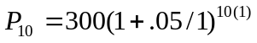 = $488.67

7. a. 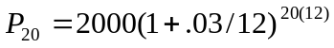 = $3641.51 in 20 years
b. 3641.51 – 2000 = $1641.51 in interest

9. 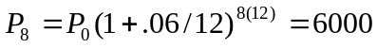. P₀ = $3717.14 would be needed

11. a. 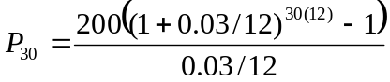 = $116,547.38
b. 200(12)(30) = $72,000
c. $116,547.40 - $72,000 = $44,547.38 of interest

13. a. 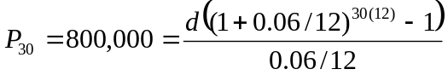 d = $796.40 each month
b. $796.40(12)(30) = $286,704
c. $800,000 - $286,704 = $513,296 in interest

15. a. 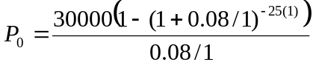 = $320,243.29
b. 30000(25) = $750,000
c. $750,000 - $320,243.29 = $429,756.71

17. 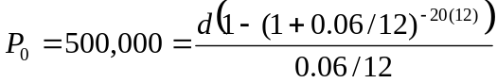 d = $3582.16 each month

19. a. 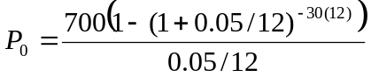 = a $130,397.13 loan
b. 700(12)(30) = $252,000
c. $252,200 - $130,397.13 = $121,602.87 in interest

21. 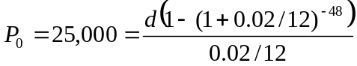 = $542.38 a month

23. a. Down payment of 10% is $20,000, leaving $180,000 as the loan amount
b. 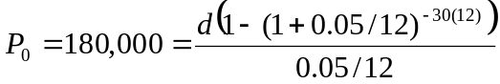 d = $966.28 a month
c. 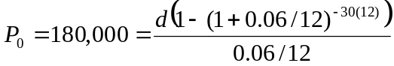 d = $1079.19 a month

25. First we find the monthly payments:
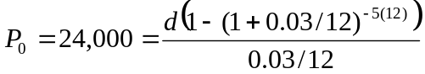. d = $431.25
Remaining balance: 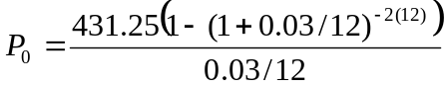 = $10,033.45

27. 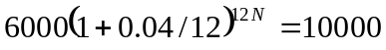
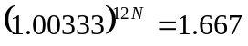
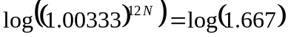
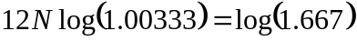
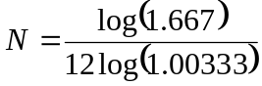 = about 12.8 years

29. 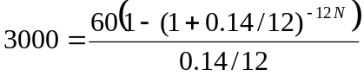
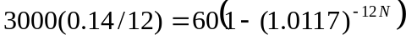
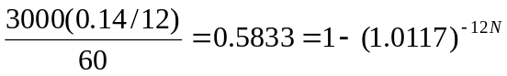
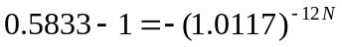
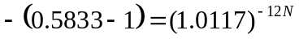
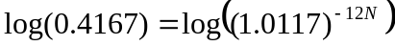
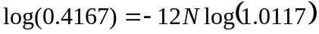
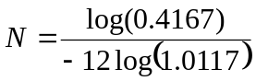 = about 6.3 years

31. First 5 years: 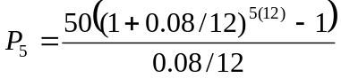 = $3673.84
Next 25 years: 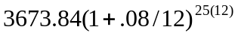 = $26,966.65

33. Working backwards, 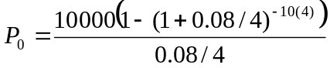 = $273,554.79 needed at retirement. To end up with that amount of money, 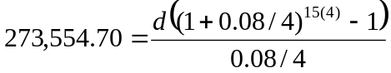. He’ll need to contribute d = $2398.52 a quarter.

Statistics
1. a. Population is the current representatives in the state’s congress
b. 106
c. the 28 representatives surveyed
d. 14 out of 28 = ½ = 50%
e. We might expect 50% of the 106 representatives = 53 representatives

3. This suffers from leading question bias

5. This question would likely suffer from a perceived lack of anonymity

7. This suffers from leading question bias

9. Quantitative

11. Observational study

13. Stratified sample

15. a. Group 1, receiving the vaccine
b. Group 2 is acting as a control group. They are not receiving the treatment (new vaccine).
c. The study is at least blind. We are not provided enough information to determine if it is double-blind.
d. This is a controlled experiment

17. a. Census
b. Observational study

Describing Data
1. a. Different tables are possible

Score | Frequency
30 | 1
40 | 0
50 | 4
60 | 3
70 | 6
80 | 5
90 | 2
100 | 3

b. This is technically a bar graph, not a histogram: 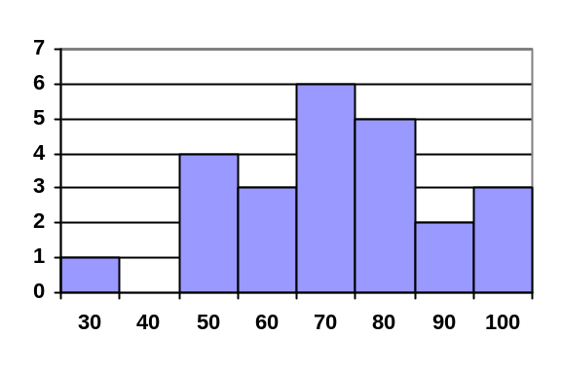
c.
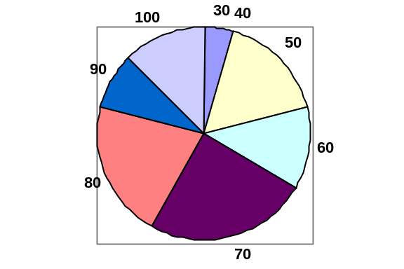

3. a. 5+3+4+2+1 = 15
b. 5/15 = 0.3333 = 33.33%

5. Bar is at 25%. 25% of 20 = 5 students earned an A

7. a. (7.25+8.25+9.00+8.00+7.25+7.50+8.00+7.00)/8 = $7.781
b. In order, 7.50 and 8.00 are in middle positions. Median = $7.75
c. 0.25*8 = 2. Q1 is average of 2nd and 3rd data values: $7.375
0.75*8 = 6. Q3 is average of 6th and 7th data values: $8.125
5-number summary: $7.00, $7.375, $7.75, $8.125, $9.00
d. 0.637

9. a. (5*0 + 3*1 + 4*2 + 2*3 + 1*5)/15 = 1.4667
b. Median is 8th data value: 1 child
c. 0.25*15 = 3.75. Q1 is 4th data value: 0 children
0.75*15 = 11.25. Q3 is 12th data value: 2 children
5-number summary: 0, 0, 1, 2, 5
d. 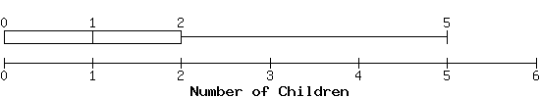

11. Kendra makes $90,000. Kelsey makes $40,000. Kendra makes $50,000 more.

Probability
1. a. 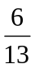 b,. 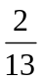 3. 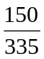 = 44.8%

5.  7. 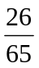

9. 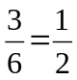 11. 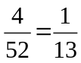

13. 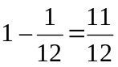 15. 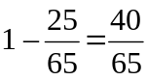

17. 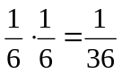 19. 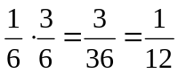

21. 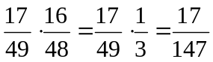

23. a. 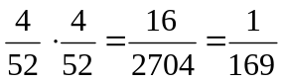

b. 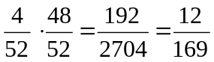
c. 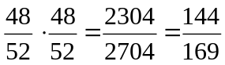
d. 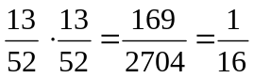
e. 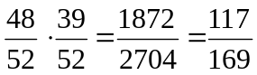

25. 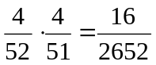

27. a. 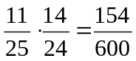
b. 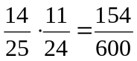
c. 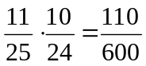
d. 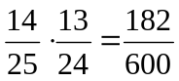
e. no males = two females. Same as part d.

29. P(F and A) = 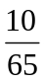

31. P(red or odd) = 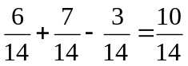. Or 6 red and 4 odd-numbered blue marbles is 10 out of 14.

33. P(F or B) = 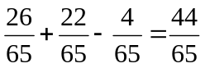. Or P(F or B) = 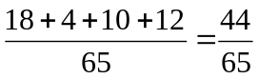

35. P(King of Hearts or Queen) = 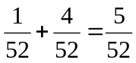

37. a. P(even | red) =  b. P(even | red) = 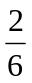

39. P(Heads on second | Tails on first) = . They are independent events.

41. P(speak French | female) = 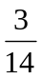

43. Out of 4,000 people, 10 would have the disease. Out of those 10, 9 would test positive, while 1 would falsely test negative. Out of the 3990 uninfected people, 399 would falsely test positive, while 3591 would test negative.
a. P(virus | positive) = 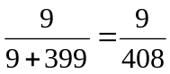 = 2.2%
b. P(no virus | negative) = 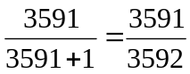 = 99.97%

45. Out of 100,000 people, 300 would have the disease. Of those, 18 would falsely test negative, while 282 would test positive. Of the 99,700 without the disease, 3,988 would falsely test positive and the other 95,712 would test negative.
P(disease | positive) = 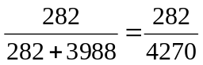 = 6.6%

47. Out of 100,000 women, 800 would have breast cancer. Out of those, 80 would falsely test negative, while 720 would test positive. Of the 99,200 without cancer, 6,944 would falsely test positive.
P(cancer | positive) = 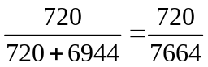 = 9.4%

49. 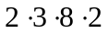 = 96 outfits

51. a. 4 · 4 · 4 = 64 b. 4 · 3 · 2 = 24

53. 26 · 26 · 26 · 10 · 10 · 10 = 17,576,000

55. ₄P₄ or 4 · 3 · 2 · 1 = 24 possible orders

57. Order matters. ₇P₄ = 840 possible teams

59. Order matters. ₁₂P₅ = 95,040 possible themes

61. Order does not matter. ₁₂C₄ = 495

63. ₅₀C₆ = 15,890,700

65. ₂₇C₁₁ · 16 = 208,606,320

67. There is only 1 way to arrange 5 CD's in alphabetical order. The probability that the CD's are in alphabetical order is one divided by the total number of ways to arrange 5 CD's. Since alphabetical order is only one of all the possible orderings you can either use permutations, or simply use 5!. P(alphabetical) = 1/5! = 1/(5 P 5) = 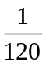.

69. There are ₄₈C₆ total tickets. To match 5 of the 6, a player would need to choose 5 of those 6, ₆C₅, and one of the 42 non-winning numbers, ₄₂C₁. 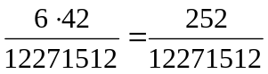

71. All possible hands is ₅₂C₅. Hands will all hearts is ₁₃C₅. 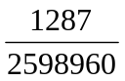.

73. 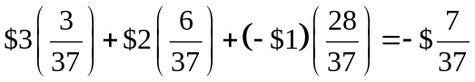 = -$0.19

75. There are ₂₃C₆ = 100,947 possible tickets.
Expected value = 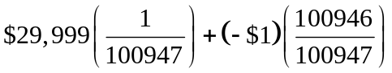 = -$0.70

77. 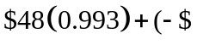302)(0.007) = $45.55

Sets
1. {m, i, s, p} 3. One possibility is: Multiples of 3 between 1 and 10

5. Yes 7. True

9. True 11. False

13. A ⋃ B = {1, 2, 3, 4, 5} 15. A ⋂ C = {4}

17. A^{c} = {6, 7, 8, 9, 10} 19. D^{c} ⋂ E = {t, s}

21. (D ⋂ E) ⋃ F = {k, b, a, t, h} 23. (F ⋂ E)^{c} ⋂ D = {b, c, k}

25. 27.
F
E
D
F
E
D

29. One possible answer: (A ⋂ B) ⋃ (B ⋂ C)

31. (A ⋂ B^{c}) ⋃ C 33. 5

35. 6 37. n(A ⋂ C) = 5

39. n(A ⋂ B ⋂ C^{c}) = 3 41. n(G ⋃ H) = 45

43. 136 use Redbox

45. a) 8 had seen exactly one b) 6 had only seen SW
M
LotR
SW
2
6
0
4
6
8
6

Historical Counting

1. Partial answer: Jars: 3 singles, 3 @ x3, 2 @ x6, 1 @ x12. 3+9+12+12 = 36

3. 113

5. 3022

7. 53

9. 1100100

11. 332

13. 111100010

15. 7,1,10 base 12 = 1030 base 10

17. 6,4,2 base 12 = 914 base 10

19. 175 base 10 = 1,2,7 base 12 = 

21. 10000 base 10 = 5,9,5,4 base 12 = 

23. 135 = 6,15 base 20 =


25. 360 = 18,0 base 20 =

27. 10500 = 1,6,5,0 base 20

29. 1,2,12 base 20 = 452 base 10

31. 3,0,3 base 20 = 1203 base 10

33. 32 + 11 = 1,12₂₀ + 11₂₀ = 1,23₂₀ = 2,3₂₀ = 43

35. 35 + 148 = 1,15₂₀ + 7,8₂₀ = 8,23₂₀ = 9,3₂₀ = 183

37. 450 + 844 = 1,2,10₂₀ + 2,2,4₂₀ = 3,4,14₂₀ = 1294

Fractals
1.
Step 2
Step 3

3.
Step 2
Step 3
5.
Step 2
Step 3

9. Four copies of the Koch curve are needed to create a curve scaled by 3. 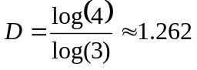
1
3

11. Eight copies of the shape are needed to make a copy scaled by 3. 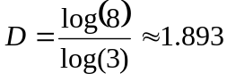
13. 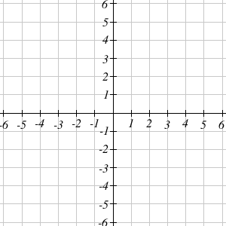
imaginary
real
–3i
4
–2 + 3i
2 + i

15. a) 5 – i b) 5 – 4i

17. a) 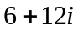 b) 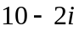 c) 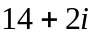
imaginary
real
2 + 3i
5 + i

19. 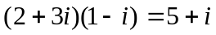. It appears that multiplying by 1 – i both scaled the number away from the origin, and rotated it clockwise about 45°.

21. 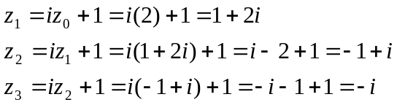

23. 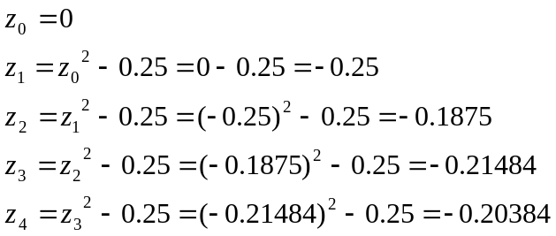

25. attracted, to approximately -0.37766 + 0.14242i

27. periodic 2-cycle 29. Escaping 31. periodic 3-cycle

33. a) Yes, periodic 3-cycle b) Yes, periodic 3-cycle c) No

Cryptography
1. ZLU KZB WWS PLZ 3. SHRED EVIDENCE

5. O2H DO5 HDV 7. MERGER ON

9. MNI YNE TBA AEH RTA TEA TAI LRE A

11. THE STASH IS HIDDEN AT MARVINS QNS

13. UEM IYN IOB WYL TTL N

15. HIRE THIRTY NEW EMPLOYEES MONDAY

17. ZMW NDG CDA YVK

19. a) 3 b) 0 c) 4

21. We test out all n from 1 to 10
n | 4^{n} | 4^{n} mod 11
1 | 4 | 4
2 | 16 | 5
3 | 64 | 9
4 | 256 | 3
5 | 1024 | 1
6 | 4096 | 4
7 | 16384 | 5
8 | 65536 | 9
9 | 262144 | 3
10 | 1048576 | 1
Since we have repeats, and not all values from 1 to 10 are produced (for example, there is no n is 4^{n} mod 11 = 7), 4 is not a generator mod 11.

23. 157¹⁰ mod 5 = (157 mod 5)¹⁰ mod 5 = 2¹⁰ mod 5 = 1024 mod 5 = 4

25. 3⁷ mod 23 = 2

27. Bob would send 5⁷ mod 33 = 14. Alice would decrypt it as 14³ mod 33 = 5

31. a. 67⁸ mod 83 = (67⁴ mod 83)² mod 83 = 49² mod 83 = 2401 mod 83 = 77
67¹⁶ mod 83 = (67⁸ mod 83)² mod 83 = 77² mod 83 = 5929 mod 83 = 36

b. 17000 mod 83 = (100 mod 83)*(170 mod 83) mod 83 = (17)(4) mod 83 = 68

c. 67⁵ mod 83= (67⁴ mod 83)(67 mod 83) mod 83 = (49)(67) mod 83 = 3283 mod 83 = 46

d. 67⁷ mod 83= (67⁴ mod 83) (67² mod 83)(67 mod 83) mod 83 = (49)(7)(67) mod 83 = 22981 mod 83 = 73.

e. 67²⁴ = 67¹⁶67⁸ so
67²⁴ mod 83 = (67¹⁶ mod 83)(67⁸ mod 83) mod 83 = (77)(36) mod 83 = 2272 mod 83 = 33

Logic
Boolean Logic

1. {5, 15, 25, …}

Quantified Statements

3. At least one person did not fail the quiz today.

Truth Tables

5. a. Elvis is alive or did not gain weight.
b. It is not the case that Elvis is alive and gained weight.
c. If Elvis gained weight, then he is not alive.
d. Elvis is alive if and only if he did not gain weight.

7.
A | B | ~A | ~A ⋁ B | ~(~A ⋁ B)
T | T | F | T | F
T | F | F | F | T
F | T | T | T | F
F | F | T | T | F

9.
A | B | C | A ⋁ B | ~C | (A ⋁ B) → ~C
T | T | T | T | F | F
T | T | F | T | T | T
T | F | T | T | F | F
T | F | F | T | T | T
F | T | T | T | F | F
F | T | F | T | T | T
F | F | T | F | F | T
F | F | F | F | T | T

11.
A | B | A ∨ B
T | T | F
T | F | T
F | T | T
F | F | F

13. The results are identical; the exclusive or translates to “(A or B) and not (A and B)”.

Conditional Statements

15. a. Not necessarily true; this is the inverse. You could get your mouth washed out for some other reason.
b. True; this is the contrapositive.
c. Not necessarily true; this is the converse. You could get your mouth washed out for some other reason.

17. Luke faces Vader and Obi-Wan interferes.

19. a. This couldn’t happen; you fulfilled your part of the bargain but your coach didn’t.
b. This couldn’t happen; you didn’t fulfill your part of the bargain but your coach let you play anyway. This could happen with a conditional statement, but not a biconditional.
c. This could happen; practice = play, no practice = no play.

De Morgan’s Laws

21. You don’t need a dated receipt or you don’t need your credit card to return this item.

Deductive Arguments

23. Valid, by the law of contraposition.

25. Valid, by disjunctive syllogism.

27. Invalid; we are using the inclusive or, so the sets of people with a pencil and people with a pen could possibly overlap. Marcie might be in the intersection of the two sets.

Logical Fallacies

29. False dilemma; you could fly, take a bus, hitchhike…

31. Correlation implies causation; maybe the only time our smoke detector goes off is when I burn dinner, and the kids choose to eat cereal whenever I burn dinner.

